LAB3_4

setwd(".")  
library(knitr)  
library(ggplot2)  
library(sqldf)

## Loading required package: gsubfn

## Loading required package: proto

## Loading required package: RSQLite

library(DMwR2)

## Registered S3 method overwritten by 'xts':  
## method from  
## as.zoo.xts zoo

## Registered S3 method overwritten by 'quantmod':  
## method from  
## as.zoo.data.frame zoo

library(e1071)

#APARTADO A

mu<-200  
sigma<-250  
Wdcha<-pnorm(250,200,25)  
Wizq<-pnorm(200,200,25)  
direfer<-Wdcha-Wizq

#APARTADO B

Px255<-1-pnorm(255,200,25)

#APARTADO C

Percentil 95*percentil 5

p05<-qnorm(0.05,200,25)  
p95<-qnorm(0.95,200,25)

#APARTADO D

Generamos una muestra de 34600

set.seed(34600)  
muestra<-rnorm(1000,200,25)  
hist(muestra, freq=F, col="lightblue", density=25, ylim=c(0,2*max(Px255)))  
abline(v=mean(muestra), col="blue",lwd=1)

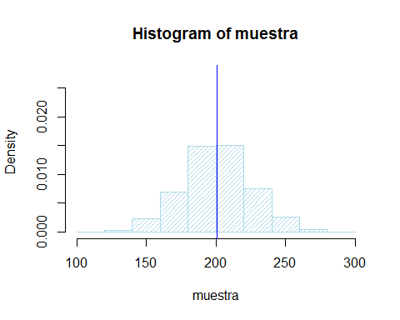

#APARTADO E

x<-seq(min(muestra),max(muestra),0.1)  
fx<-dnorm(x,200,25)  
hist(muestra, freq=F, col="lightblue", density=25, ylim=c(0,max(fx)))  
abline(v=mean(muestra), col="blue",lwd=1)  
points(x,fx,col="red",lwd=0.5)

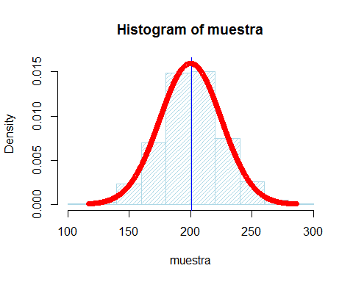

fhist<-hist(muestra, col="lightblue")

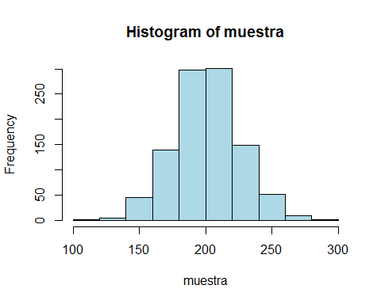

f_x<-cumsum(fhist$counts)/sum(fhist$counts)  
x_ac<-fhist$breaks[2:length(fhist$breaks)]  
plot(x_ac,f_x, type="h", lwd=2, col="green",  
 xlab="Cantidad", ylab="probabilidad")  
grid()  
f_xt<-pnorm(x_ac,200,25)  
points(x_ac,f_xt,type="l",col="blue", lwd=2)  
abline(h=direfer,col="red",lwd=3)  
abline(h=Px255,col="brown", lwd=3)

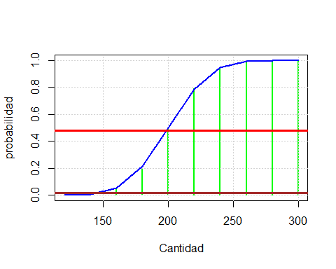 #APARTADO F

skewness(muestra)

## [1] 0.08306719

kurtosis(muestra)

## [1] 0.1653612

Es asimetrica muy ligeramente positiva y poco aplastada Mesocurtica ```